Regular Verb Definition

Unlike [irregular verbs](https://eslgrammar.org/irregular-past-tense-verbs/), those verbs that form their past participle with ‘d’ or ‘ed’ are regular verbs. These verbs do not undergo substantial changes while changing forms between tenses.

1. **If the verb ends with a vowel, only ‘d’ is added. For example:**

|  |  |
| --- | --- |
| **PRESENT TENSE** | **PAST TENSE** |
| Share | Shared |
| Scare | Scared |
| Dare | Dared |

1. **If the verb ends with a consonant, ‘ed’ is added. For example:**

|  |  |
| --- | --- |
| **PRESENT TENSE** | **PAST TENSE** |
| Want | Wanted |
| Shout | Shouted |
| Kill | Killed |

Regular Verbs List

Useful regular [verbs list](https://7esl.com/english-verbs/) in English.

|  |  |  |
| --- | --- | --- |
| **BASE FORM** | **SIMPLE PAST** | **PAST PARTICIPLE** |
| Accept | Accepted | Accepted |
| Achieve | Achieved | Achieved |
| Add | Added | Added |
| Admire | Admired | Admired |
| Admit | Admitted | Admitted |
| Adopt | Adopted | Adopted |
| Advise | Advised | Advised |
| Agree | Agreed | Agreed |
| Allow | Allowed | Allowed |
| Announce | Announced | Announced |
| Appreciate | Appreciated | Appreciated |
| Approve | Approved | Approved |
| Argue | Argued | Argued |
| Arrive | Arrived | Arrived |
| Ask | Asked | Asked |
| Assist | Assisted | Assisted |
| Attack | Attacked | Attacked |
| Bake | Baked | Baked |
| Beg | Begged | Begged |
| Behave | Behaved | Behaved |
| Boil | Boiled | Boiled |
| Borrow | Borrowed | Borrowed |
| Brush | Brushed | Brushed |
| Bury | Buried | Buried |
| Call | Called | Called |
| Challenge | Challenged | Challenged |
| Change | Changed | Changed |
| Chase | Chased | Chased |
| Cheat | Cheated | Cheated |
| Cheer | Cheered | Cheered |
| Chew | Chewed | Chewed |
| Clap | Clapped | Clapped |
| Clean | Cleaned | Cleaned |
| Collect | Collected | Collected |
| Compare | Compared | Compared |
| Complain | Complained | Complained |
| Confess | Confessed | Confessed |
| Construct | Constructed | Constructed |
| Control | Controlled | Controlled |
| Copy | Copied | Copied |
| Count | Counted | Counted |
| Create | Created | Created |
| Cry | Cried | Cried |
| Cycle | Cycled | Cycled |
| Damage | Damaged | Damaged |
| Dance | Danced | Danced |
| Deliver | Delivered | Delivered |
| Destroy | Destroyed | Destroyed |
| Divide | Divided | Divided |
| Drag | Dragged | Dragged |
| Earn | Earned | Earned |
| Employ | Employed | Employed |
| Encourage | Encouraged | Encouraged |
| Enjoy | Enjoyed | Enjoyed |
| Establish | Established | Established |
| Estimate | Estimated | Estimated |
| Exercise | Exercised | Exercised |
| Expand | Expanded | Expanded |
| Explain | Explained | Explained |
| Fry | Fried | Fried |
| Gather | Gathered | Gathered |
| Greet | Greeted | Greeted |
| Guess | Guessed | Guessed |
| Harass | Harassed | Harassed |
| Hate | Hated | Hated |
| Help | Helped | Helped |
| Hope | Hoped | Hoped |
| Identify | Identified | Identified |
| Interrupt | Interrupted | Interrupted |
| Introduce | Introduced | Introduced |
| Irritate | Irritated | Irritated |
| Joke | Joked | Joked |
| Jump | Jumped | Jumped |
| Kick | Kicked | Kicked |
| Kill | Killed | Killed |
| Kiss | Kissed | Kissed |
| Laugh | Laughed | Laughed |
| Lie | Lied | Lied |
| Like | Liked | Liked |
| Listen | Listened | Listened |
| Love | Loved | Loved |
| Marry | Married | Married |
| Measure | Measured | Measured |
| Move | Moved | Moved |
| Murder | Murdered | Murdered |
| Need | Needed | Needed |
| Obey | Obeyed | Obeyed |
| Offend | Offended | Offended |
| Offer | Offered | Offered |
| Open | Opened | Opened |
| Paint | Painted | Painted |
| Park | Parked | Parked |
| Phone | Phoned | Phoned |
| Pick | Picked | Picked |
| Play | Played | Played |
| Pray | Prayed | Prayed |
| Print | Printed | Printed |
| Pull | Pulled | Puled |
| Punch | Punched | Punched |
| Punish | Punished | Punished |
| Purchase | Purchased | Purchased |
| Push | Pushed | Pushed |
| Question | Questioned | Questioned |
| Race | Raced | Raced |
| Relax | Relaxed | Relaxed |
| Remember | Remembered | Remembered |
| Reply | Replied | Replied |
| Retire | Retired | Retired |
| Return | Returned | Returned |
| Rub | Rubbed | Rubbed |
| Scold | Scolded | Scolded |
| Select | Selected | Selected |
| Smoke | Smoked | Smoked |
| Snore | Snored | Snored |
| Stare | Stared | Stared |
| Start | Started | Started |
| Study | Studied | Studied |
| Talk | Talked | Talked |
| Thank | Thanked | Thanked |
| Travel | Travelled | Travelled |
| Trouble | Troubled | Troubled |
| Type | Typed | Typed |
| Use | Used | Used |
| Visit | Visited | Visited |
| Wait | Waited | Waited |
| Walk | Walked | Walked |
| Want | Wanted | Wanted |
| Warn | Warned | Warned |
| Wink | Winked | Winked |
| Worry | Worried | Worried |
| Yell | Yelled | Yelled |

Regular Verbs Exercise

Regular Verbs in English| Infographics

**Regular Verbs List Image 1**

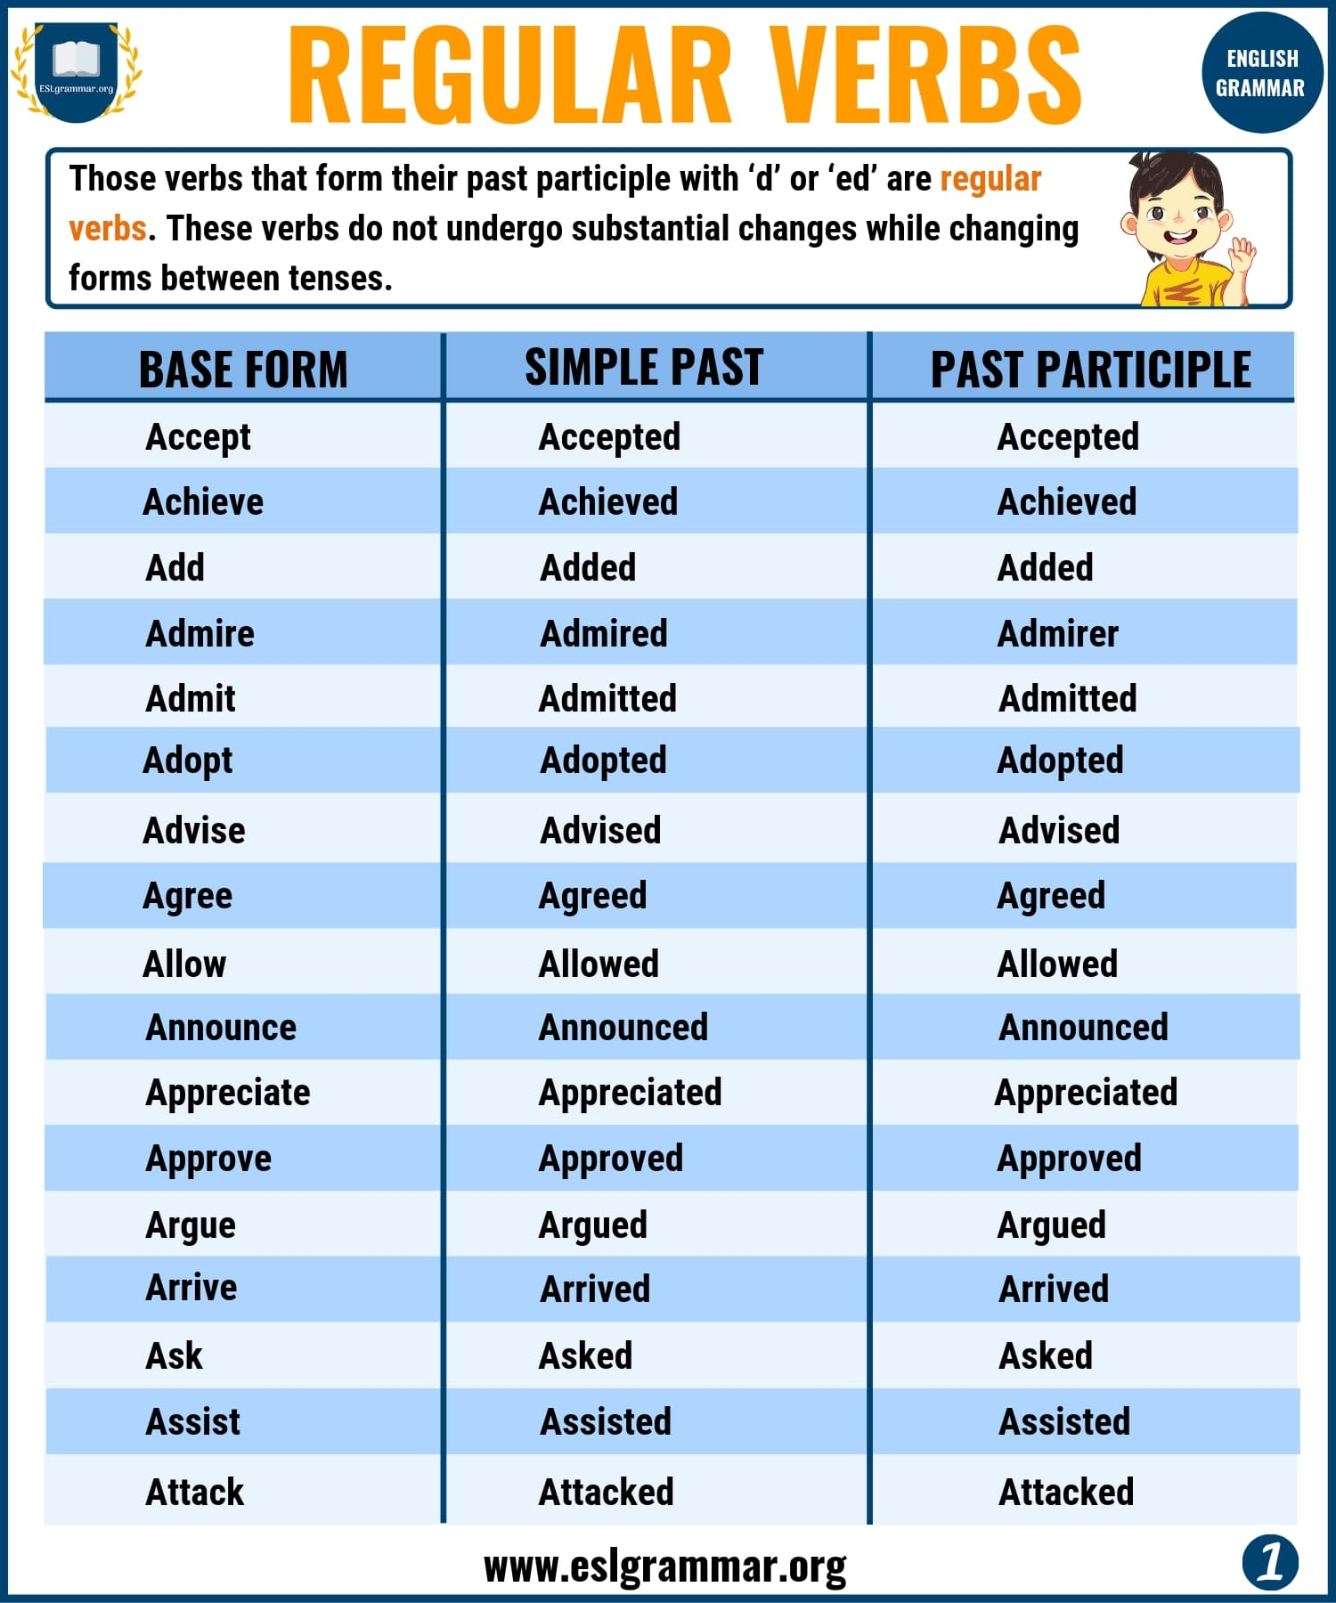Pin

**Regular Verbs List Image 2**

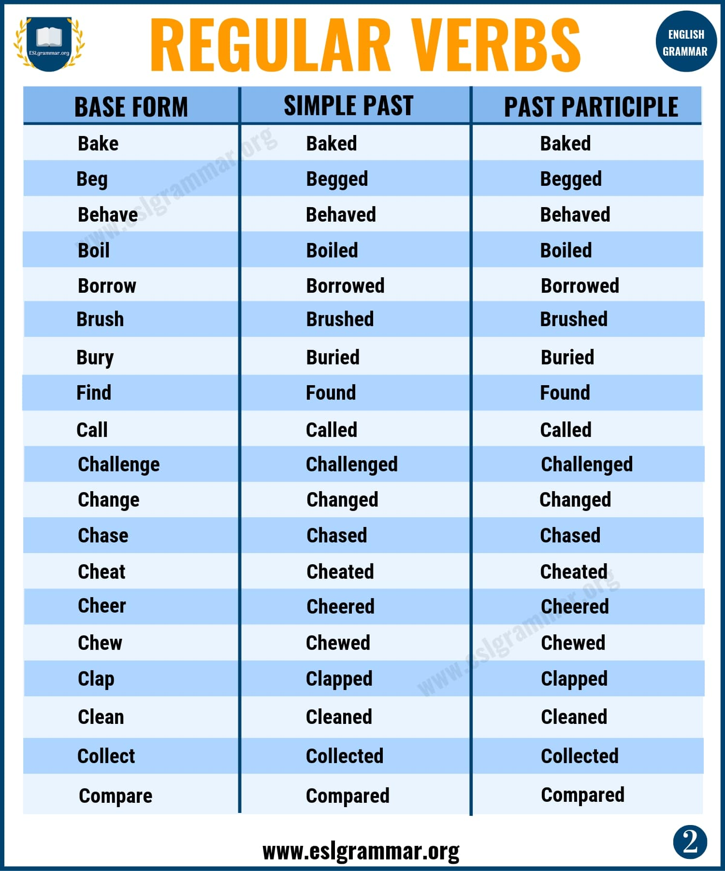

**List of Regular Verbs Image 3**

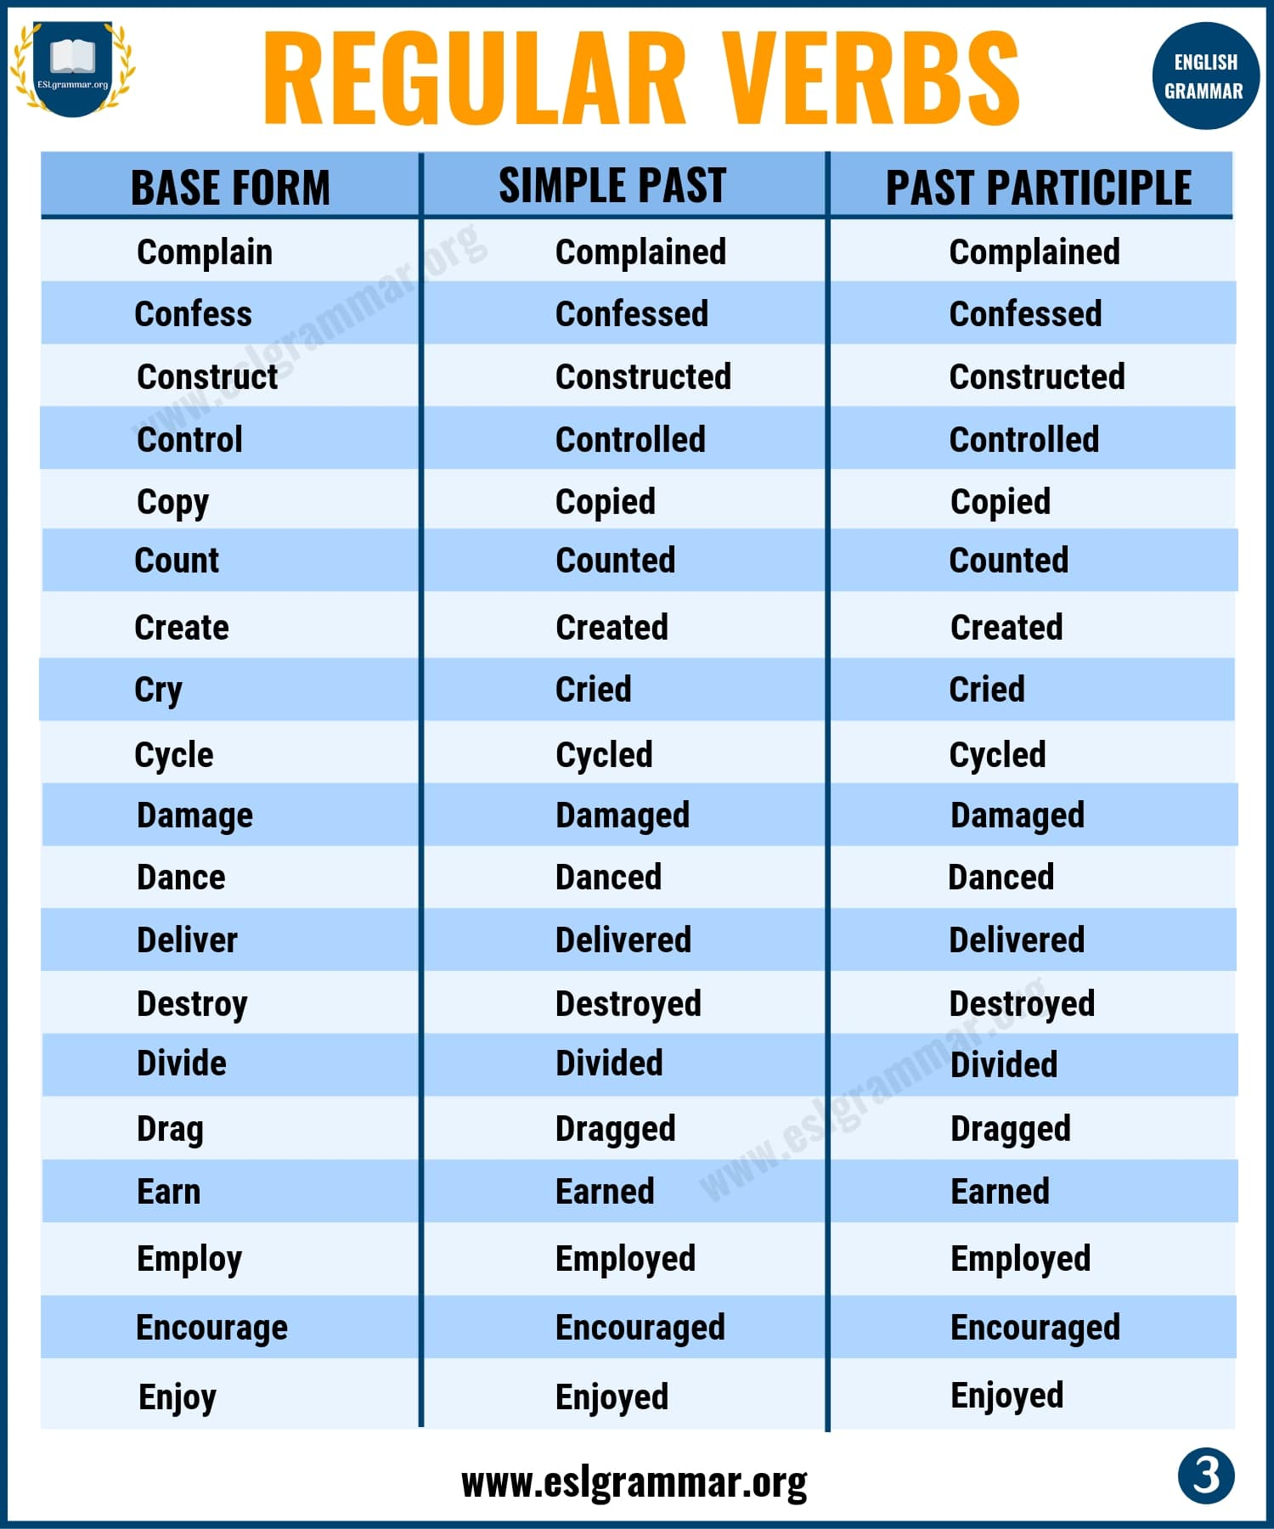Pin

**Regular Verbs List Image 4**

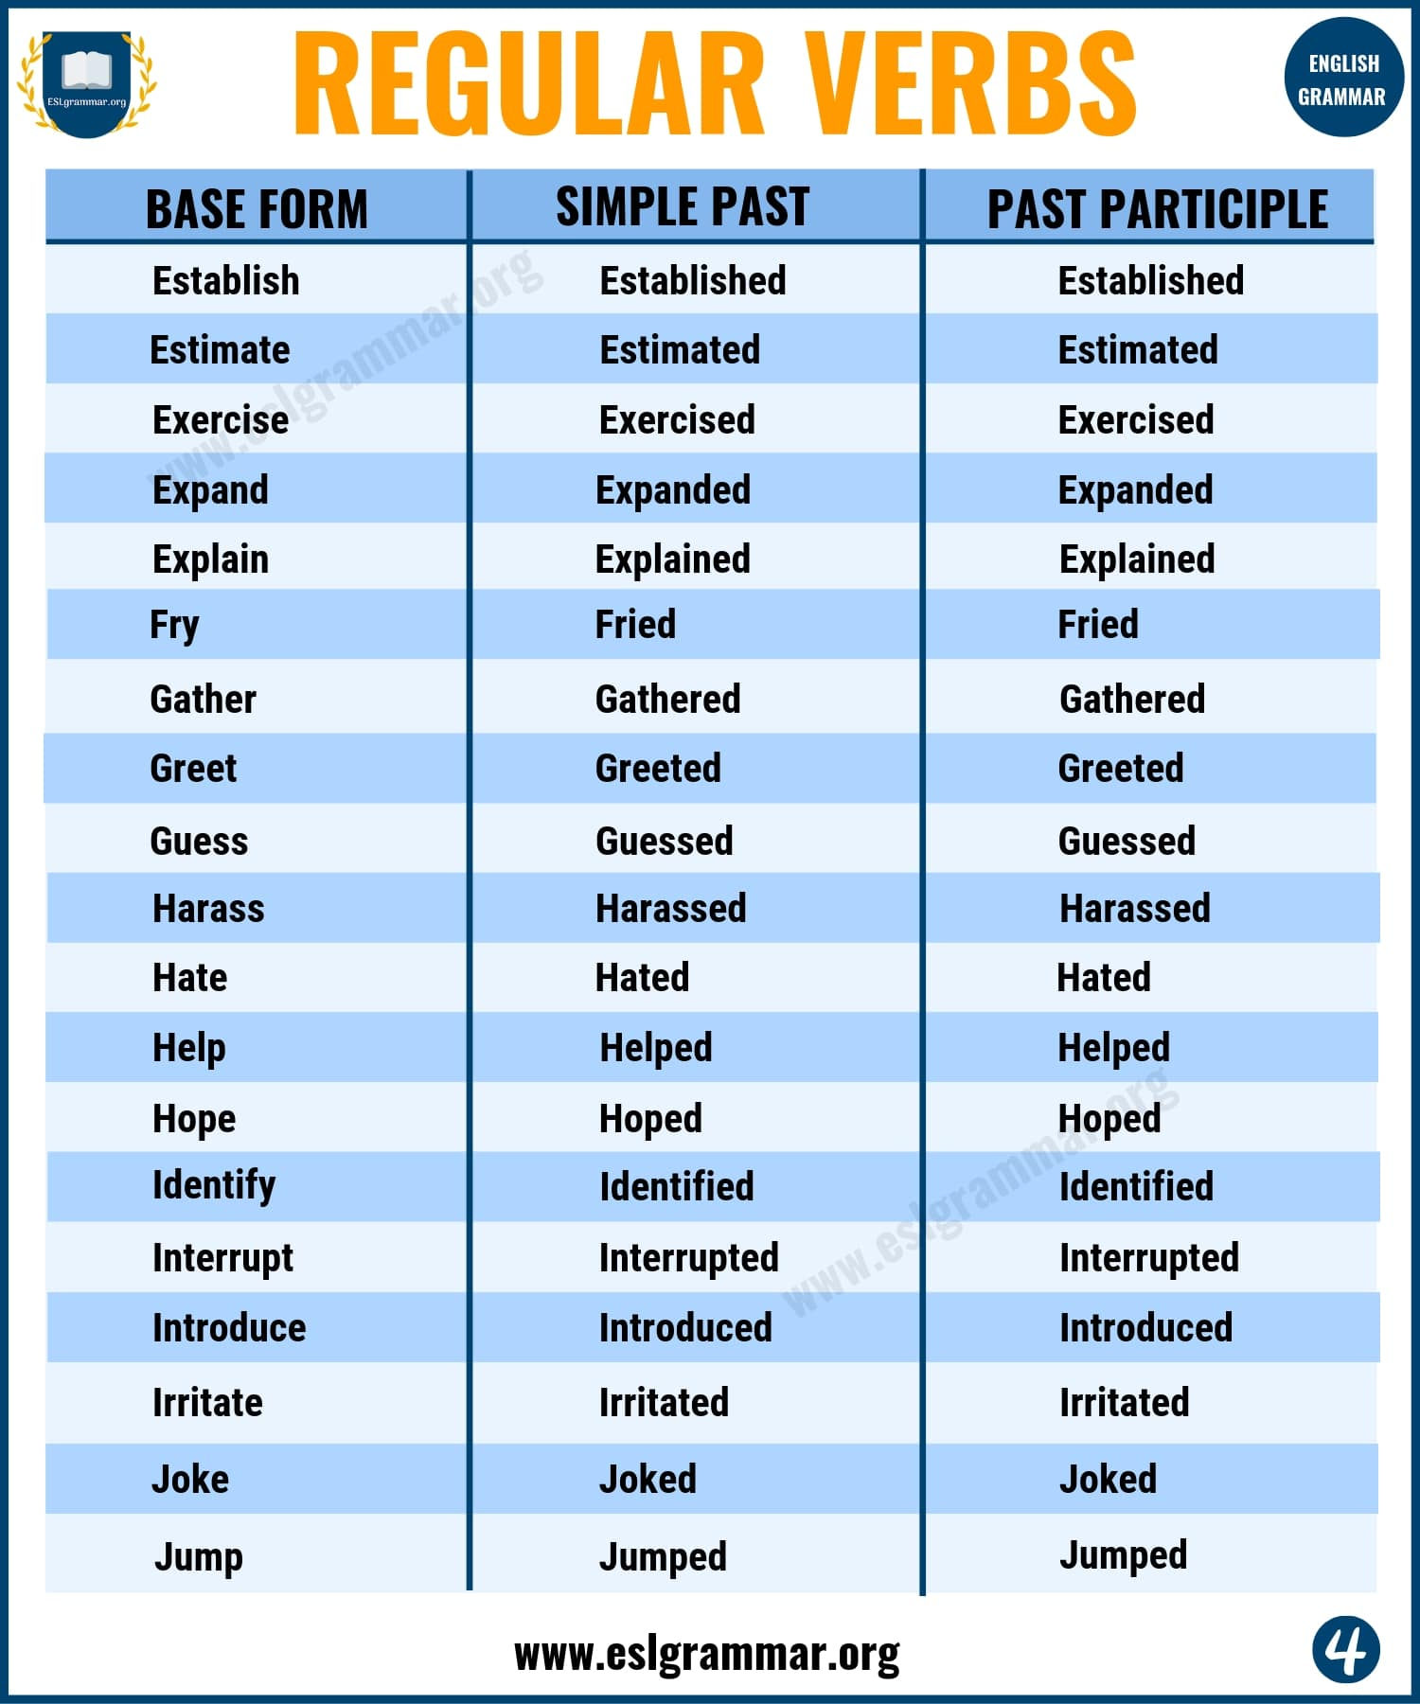Pin

**Regular Verbs List Image 5**

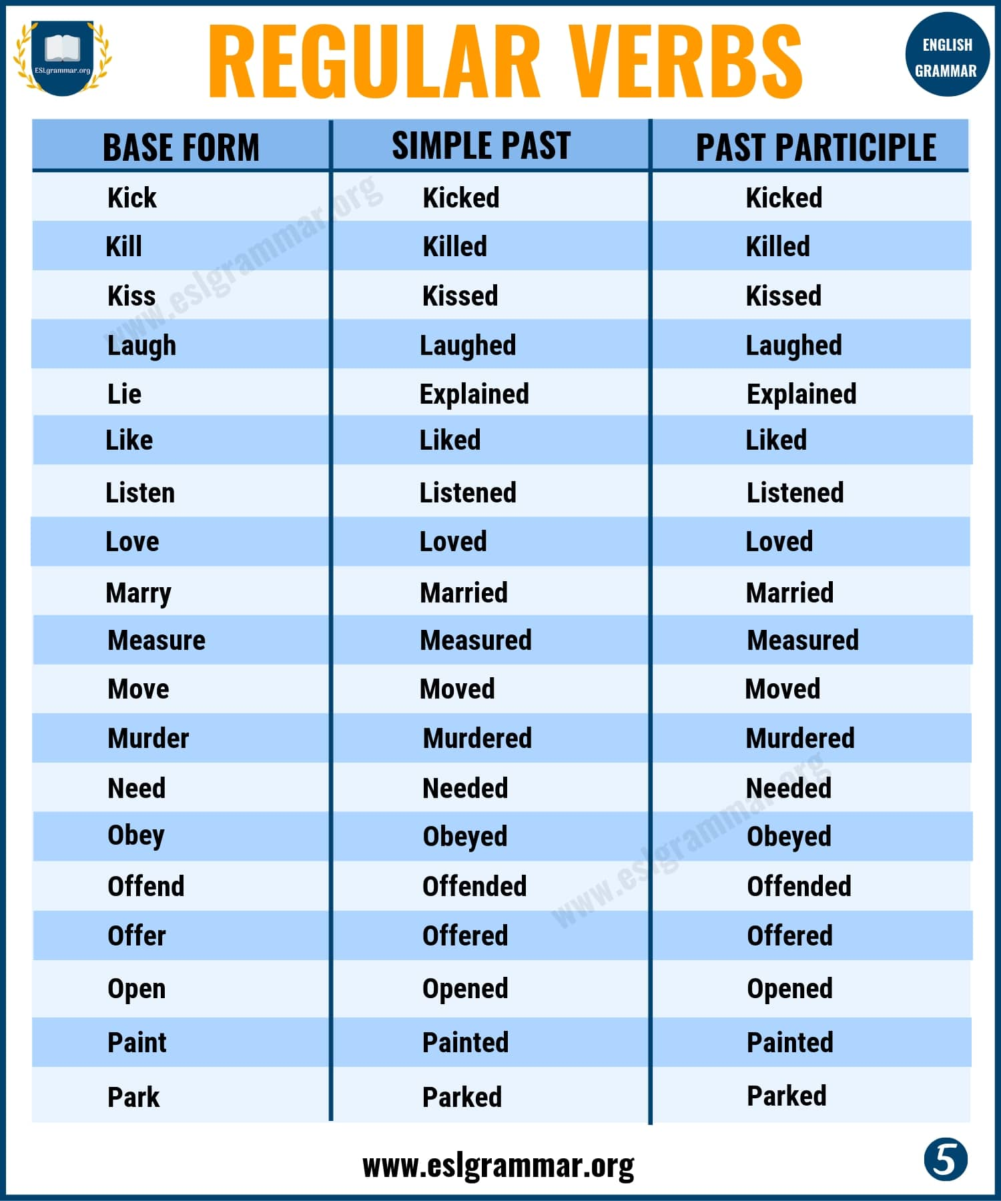Pin

**Regular Verbs List Image 6**

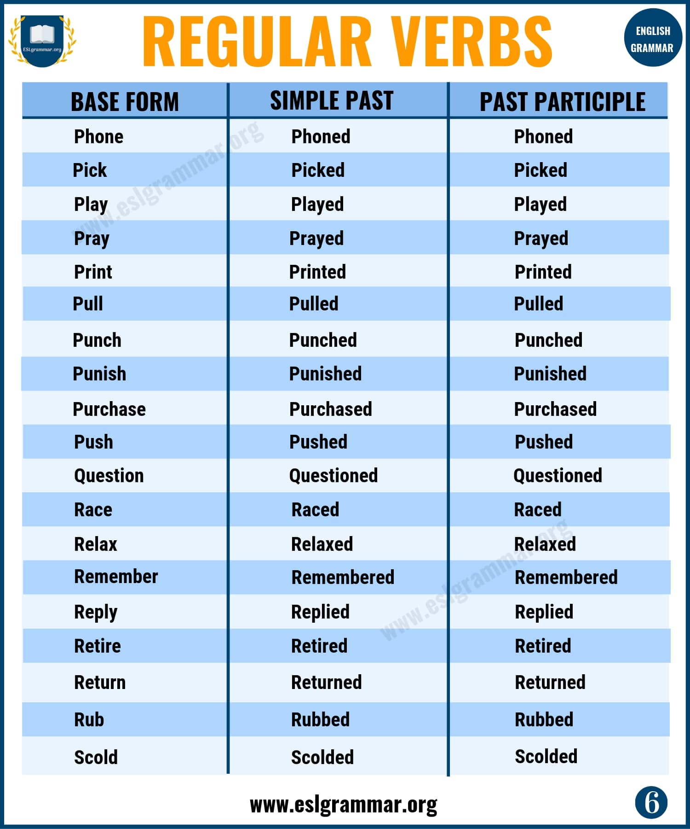Pin

**Regular Verbs List Image 7**

